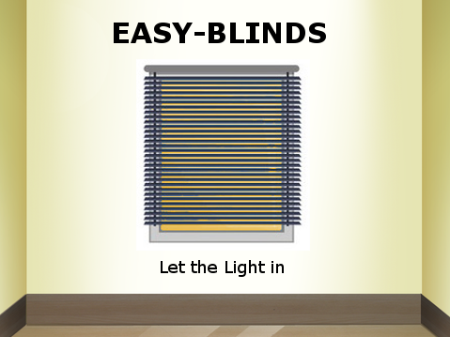

**Project Requirements Specification**

Gabriel Almeida

Ashraf Drieas

Juan Inzunza

Brandon Fins

Mandy Ledford

**1. Overview**

Easy-Blinds has set out to design a fully automated Blinds system. This design hopes to contribute to the future of a fully automated home. With Easy-Blinds installed, there will be no need to manually adjust blinds to let the sunlight in, or manually close blinds when it gets dark out. This design optimizes the usage of sunlight and minimizes electricity bills. Easy-Blinds open when the sun rises and close when the sun sets. If it gets too hot, the blinds will automatically close in order to help the user save on cooling costs by minimizing the amount of heat that enters the room.

The Easy-Blinds system is designed for anyone who desires to have an automated home and save on energy costs. The easy-to-use design allows for any home or business owner to easily control their blinds without difficulty. Complex technology lessens the appeal of a product to a large portion of consumers. Easy-Blinds avoids this issue with its easy and intuitive design. This is accomplished through the use of several sensors and wifi communication.

There are three main sensors used to automate the Easy-Blinds system: a light sensor, a motion sensor, and a temperature sensor. The light sensor allows for automation detection of sunrise and sunset. The system can be easily switched to an automatic state in which the blinds open upon detection of sunrise and close upon detection of sunset. The light sensing technology is the basis of the natural lighting optimization that makes the Easy-Blinds system so appealing. The motion sensor allows for the blinds to be open or closed with the simple wave of a hand across the top of the blinds. Lastly the temperature sensor allows for the automatic closing of the blinds when the temperature coming through the window is higher than a user specified temperature. This allows for the user to keep too much heat from entering their home through the window.

Wifi communication and an open source sdk, Flask-Ask, is used to connect and control the Easy-Blinds system through an android phone APP and voice communication with the Amazon Echo. The android App can be used to control the light and temperature sensitivity of the system, view the current temperature reading of the system, change the current state of the system to auto (controlled by light and temperature sensor) or manual (manually opened and closed by user), and turn the system on or off. Through voice communication with the Amazon Echo, the blinds can be opened and closed with a simple voice command.

Several products on the market are similar to the Easy-Blinds. One such product is MySmartBlinds. MySmartBlinds feature sun-tracking, bluetooth connection, a schedule setter, an energy savings mode, and battery updates. MySmartBlinds have a retail cost of over $200. Easy-Blinds will be able to offer similar capabilities at a much lower price point. Easy-Blinds can be manufactured at a cost of approximately $50. Easy-Blinds allow any consumer to automate their home and cut down on energy costs at an affordable price.

**2. Statement of the Problem**

Easy Blinds need to:

1. Open when the sun rises
2. Close when the sun sets
3. Close when the temperature outside is too high
4. Close when the owner runs his/her hand across the top of the blinds
5. Allow full control of the system through the Easy-Blinds Android App
6. Respond to voice commands using the Amazon Echo
7. Have minimal setup time and effort
8. Be easy to use for the majority of consumers

**3. Operational Description**

1. Automated controls
   * Light Sensor - The light sensor will control the automatic opening and closing of the blinds based on the amount of sunlight the sensor senses. The user has no interaction with this element of the design.
   * Temperature Sensor - The temperature sensor will control the automatic closing of the blinds based on the amount of heat coming in through the window. The user has no interaction with this element of the design.
2. Manual controls
   * Easy-Blinds Android App
     1. Inputs
        1. Temperature threshold: This value controls the temperature threshold value, if the temperature goes above this value the blinds should close.
        2. Light Intensity threshold: This value controls the light intensity value, if the intensity is above this value the blinds should open, and if the intensity is below this value the blinds should close.
        3. Auto Button: This button switches the system into the AUTO state in which the blinds are fully controlled by the light intensity and temperature values.
        4. Manual Button: This button switches the system into the MANUAL state in which the blinds are fully controlled by the user inputs.
        5. Open Button: This button opens the blinds.
        6. Close Button: This button closes the blinds.
        7. On Button: This button turns the system on.
        8. Off Button: This button turns the system off.
     2. Output
        1. Temperature Display
   * Respond to voice command through Amazon Echo - The Amazon Alexa Echo Dot will be used to for voice communication between the user and Raspberry Pi. Upon saying “let the light in”, and after verbal confirmation by the Echo Dot, the blinds will open and Alexa will confirm this by letting the user know the state of the blinds.
   * Motion Sensor - The motion sensor will allow the user to close the blinds with the simple wave of a hand. When the blinds are open the user waves their hand across the top of the blinds and the blinds will close. This operation also switches the blinds into manual control to avoid reopening.

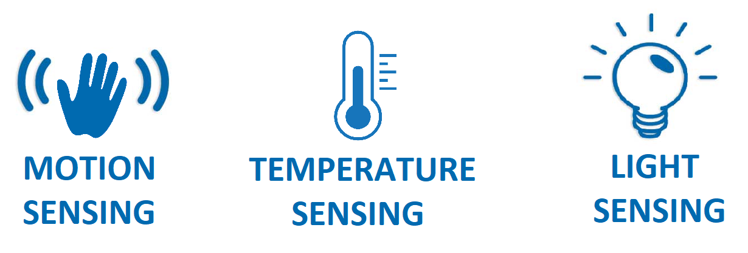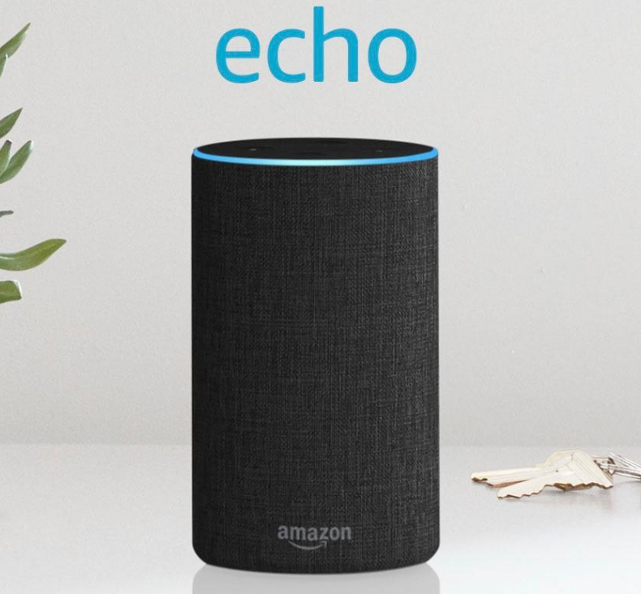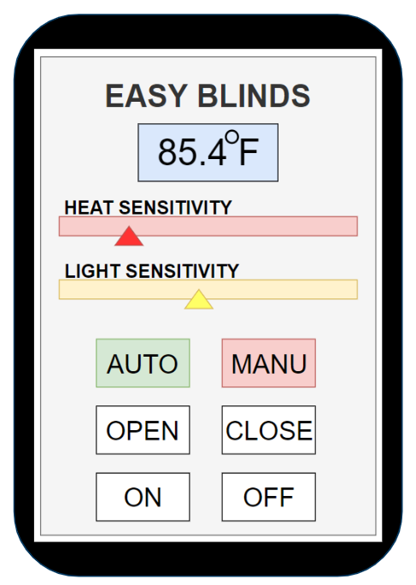



1. Setup and Operation:
   * Setup - The blinds come pre-installed with the hardware inside the top of the blinds. Once the blinds are unpackaged and you have confirmed all parts are included follow these simple instructions
     1. Hang up blinds over window of your choice
     2. Plug raspberry pi power cord into outlet
     3. Your blinds should automatically begin adjusting to the current light and temperature
   * Operation - All manual operation of blinds is done with the wave of your hand over the top of the blinds, with the Easy-Blinds App, or with a voice command to the Amazon Echo.
     1. Motion sensor - to use the motion sensor simply wave your hand over the top of the blinds when they are open and they will close. Note: this also sets the blinds into manual control, if you want to switch back to automatic control press the # button on the IR remote.
     2. Easy-Blinds App controls
        1. Heat Sensitivity - Sets temperature threshold
        2. Light Sensitivity - Sets light intensity threshold
        3. Auto Button - Puts blinds into auto control
        4. Manual Button - Puts blinds into manual control
        5. Open Button - Opens blinds
        6. Close Button - Closes blinds
        7. On Button - Activates Easy-Blinds
        8. Off Button - Deactivates Easy-Blinds
     3. Voice Control with Amazon Echo - to use this feature the user simply speaks “Alexa” followed by a voice command to the Amazon Echo. These voice commands include:
        1. To open the Easy-Blinds the user must say “Let the light in”.
        2. To close the Easy-Blinds the user must say “Let the light out”.
        3. To put the Easy-Blinds into manual control, the user must say “Manual Mode”.
        4. To put the Easy-Blinds back into automatic control, the user must say “Auto Mode”.
        5. To turn on the Easy-Blinds the user must say “Easy Blinds on”.
        6. To turn off the Easy-Blinds the user must say “Easy Blinds off”.

**4. Requirement Specification**

Easy-Blinds is powered by the Raspberry Pi, consisting of 5V provided by the wall adapter used by the Pi. The Raspberry Pi is responsible for providing power to the servo motor. The sensors, motor, and Raspberry Pi all can be secured and hidden in the upper portion of the blinds where they’ll be out of sight. Minimal changes will have to made to the blinds, which includes drilling small holes for all the sensors.

Inputs:

1. Light: The light sensor receives and records light intensity. The value of the light is constantly being monitored and compared to threshold value, set by us, which sends a signal to the raspberry pi to either open or close the blinds.
2. Temperature: The temperature sensor monitors current weather temperature readings and reports it back to the raspberry pi. Once the current temperature meets the set value to activate, the raspberry pi receives a signal to open or close the blinds.
3. Motion: The motion sensors monitors distance near the blinds using low pitched ultrasonic sound waves. The sensor is calibrated to activate when a user places their hand in front of the sensor. If the distance is less than or equal to the distance to activate, a signal from the pi is sent to the servo to open or close the blinds.
4. Voice: The Amazon Echo will be connected to the Raspberry Pi using Flask-Ask. Commands from the Echo will be sent to an online server, ngrok, to be used by Raspberry Pi. [ngrok](https://ngrok.com/) establishes a HTTP tunnel from Raspberry Pi to Alexa. Using the Amazon Skill Development Kit, user defined voice commands will added to the Echo. Commands from the Echo dot will transmitted to the server once a user defined command is spoken and confirmed by the Echo.
5. Easy-Blinds App: The easy blinds app will send commands to either an Apache server hosted on the pi or through socket communication. The raspberry pi will read in the commands and perform the specified operation.

Outputs:

Once activated, all three sensors, the Echo, and the Easy-Blinds App send signals to the raspberry pi, which controls the movement of the motor. The light sensor will signal the pi to open the blinds when the sun is out and close the blinds when it is dark outside. The temperature sensor will tell the pi to close the blinds if the temperature outside is too hot. If the blinds are open, the motion sensor will close the blinds when the user waves their hand across the top of blinds where the motion sensor is located. Lastly, the Raspberry Pi, retrieves commands from the Echo on the server and uses theses values to determine whether to open, close, change to manual, change to auto, turn on, or turn off the blinds.

**5. Design Deliverables**

1. A fully connected easy to install Easy-Blinds unit (blinds included in unit)
2. Requirements Specification document
3. Block Diagram
4. User Manual
   1. The user must position the raspberry pi onto the Easy-Blinds.
   2. The user must install the Easy-Blinds on the chosen window.
   3. Once installed, the Easy-Blinds can be opened or closed by various options depending on the users choice.
      1. The light sensor will automatically open or close based on the amount of sunlight out.
      2. The temperature sensor will automatically close based on how hot it is outside.
      3. The Echo is user controlled by voice:
         1. The Echo will either open,close, change the current state, or power on or off the blinds.
         2. Please note all commands are must be initiated by first speaking the word “Alexa”, which puts the Echo in listening mode, followed by the desired command.
      4. The motion sensor will open or close depending on the previous position when the user waves at the Easy-Blinds.
      5. The Easy-Blinds App will be used to either open, close, change the current state, or power on or off the blinds.

**6. Preliminary System Test Plan**

1. Fine-tune the rotation speed of the servo, ensuring that it is not over or under-rotating.
2. Since rig is already set up, see how everything fits together and what can be modified to attempt to self-contain everything into the concealed top portion of the blinds. Work to better conceal and compact the Pi, the wires, and other parts.
3. Test all the application features to ensure they are all giving and receiving the correct signal.
4. Connect and test the Amazon Echo with the Easy-Blinds system; test all commands.

**7. Implementation Considerations**

1. To get the Android application to work properly with our system, we must either set up an online server that will act as a relay for the system and the app or connect the APP to the pi through a socket connection. Each option has pros and cons. We must research the pros and cons of each option to decide which method would work the best for our application.
2. In order to fully implement the echo we’ll need to make sure the server is working correctly and receiving commands from the pi which the Raspberry Pi can read. To do this we’ll have to download certain libraries to Pi and configure them to work with one another and the online server. We’ll also have to make sure the Amazon Echo and/or person are in range of the Pi or Echo to be able to hear and receive commands. Lastly we’ll have to make sure only the user defined commands are sent to the server, so as to not overload and reduce the performance of the it and the Raspberry Pi.